LAB ASSIGNMENT 7

NAME:T.MD.SHAHED AKEEF

HT NO:2403A52T01

BATCH 15 CSE AIML

Task Description #1:  
• Introduce a buggy Python function that calculates the factorial of a number using recursion. Use  
Copilot or Cursor AI to detect and fix the logical or syntax errors.

Prompt: give me a buggy python function that calculates factorial of a number using recursions

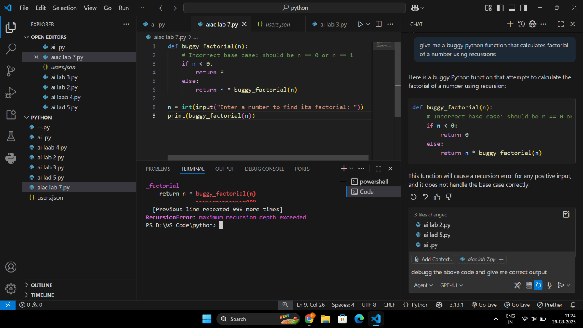

Expected Outcome #1:  
•Copilot or Cursor AI correctly identifies missing base condition or incorrect recursive call and  
suggests a functional factorial implementation

Prompt: debugg the above code and give me correct output

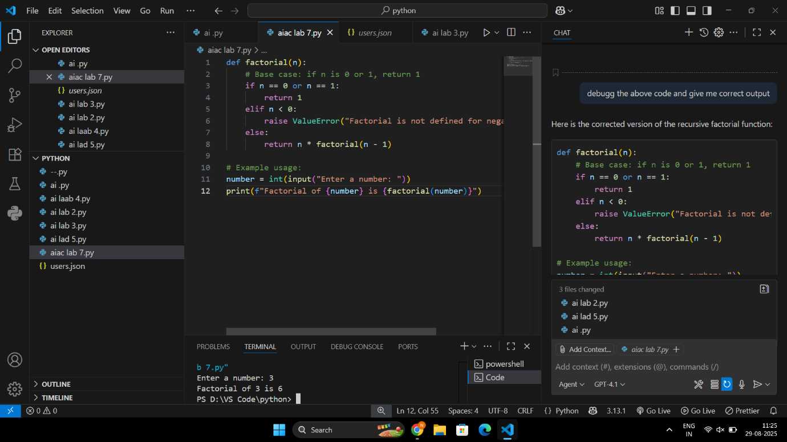

Task Description #2:  
•Provide a list sorting function that fails due to a type error (e.g., sorting list with mixed integers  
and strings). Prompt AI to detect the issue and fix the code for consistent sorting

Prompt: Provide a list sorting function that fails due to a type error (e.g., sorting list with mixed integers  
and strings

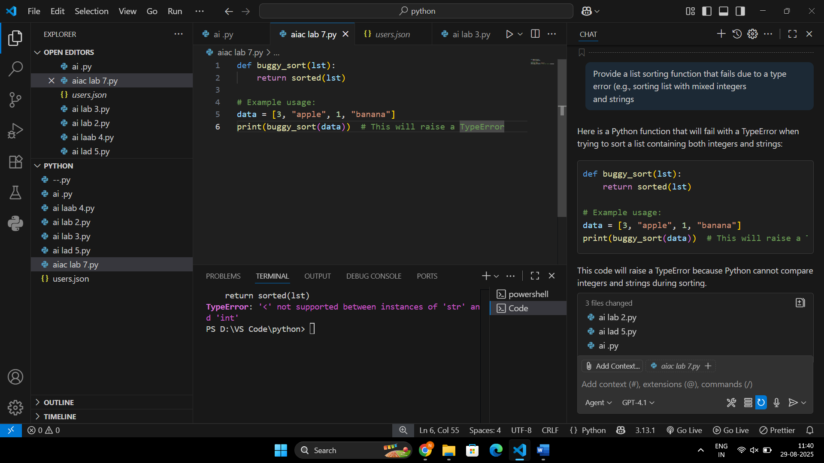

Expected Outcome #2:  
•AI detects the type inconsistency and either filters or converts list elements, ensuring successful  
sorting without a crash.

Prompt: give me correct code by debugging

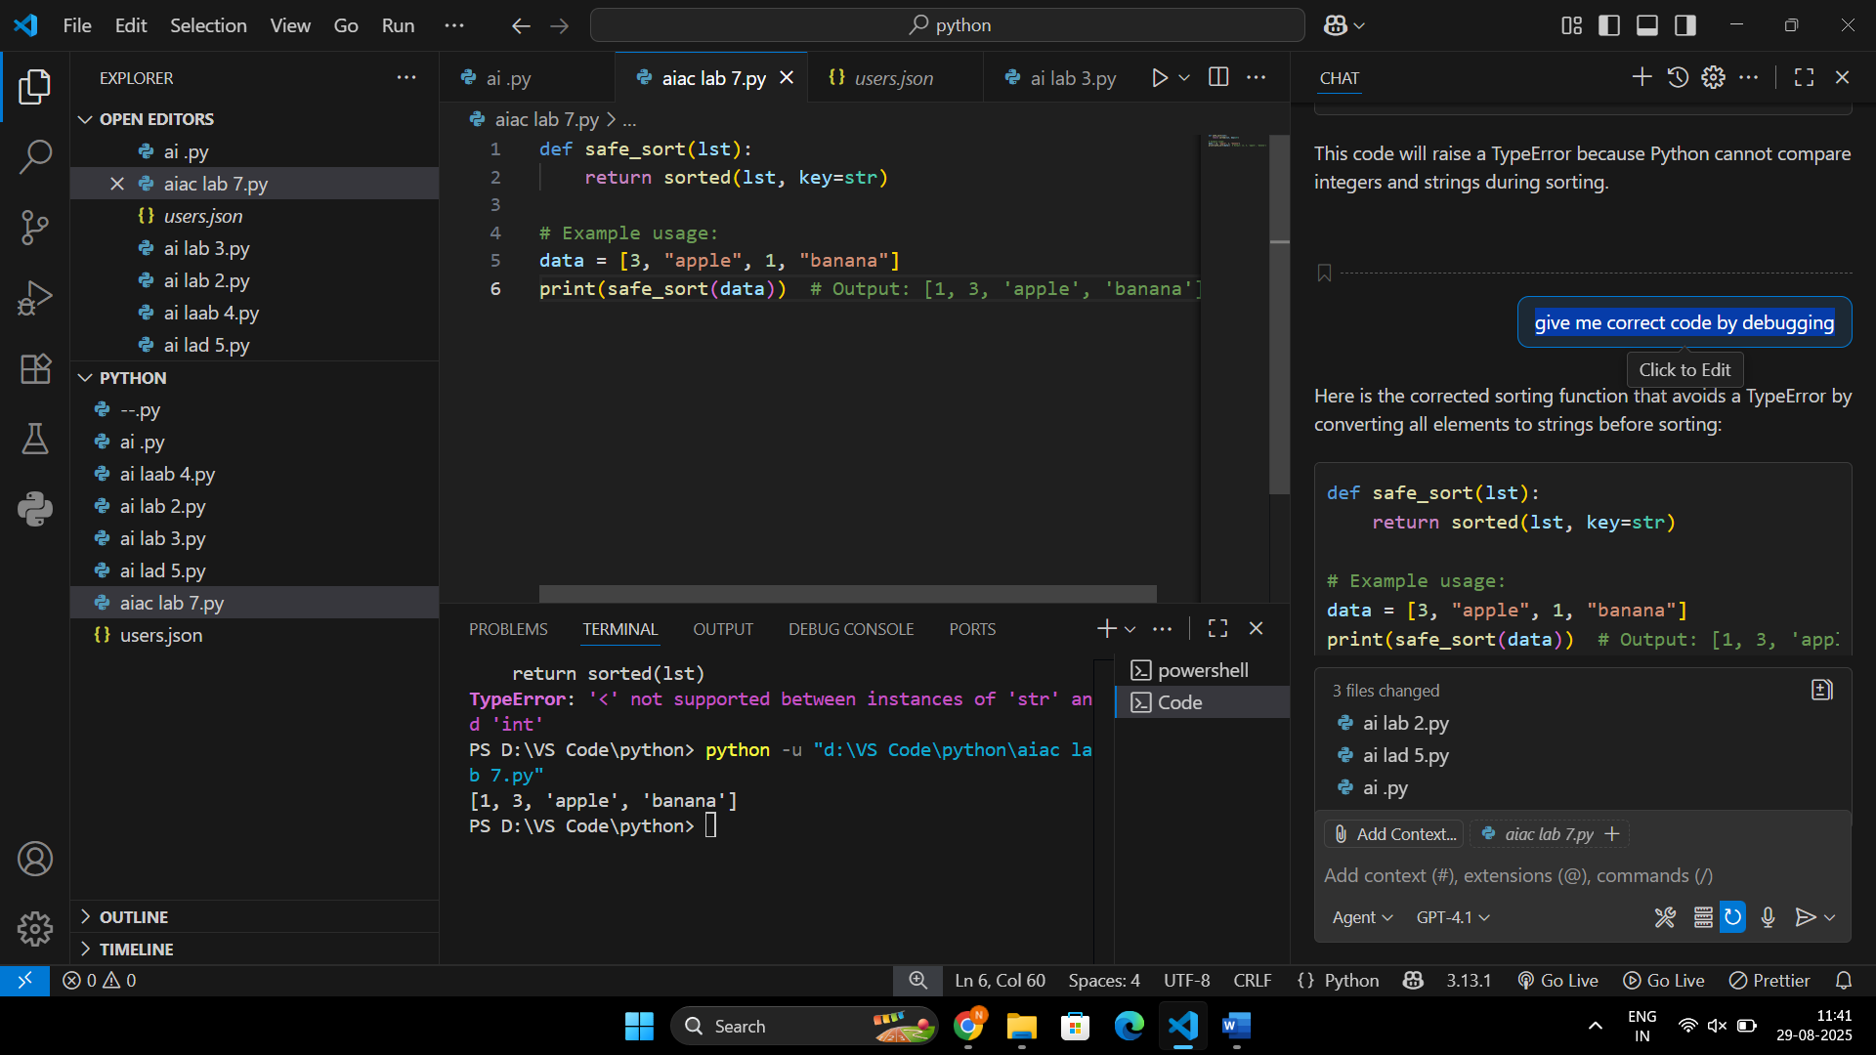

Task Description #3:  
• Write a Python snippet for file handling that opens a file but forgets to close

Prompt: 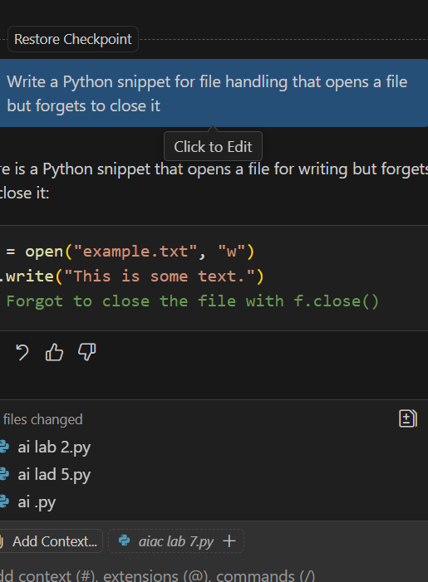

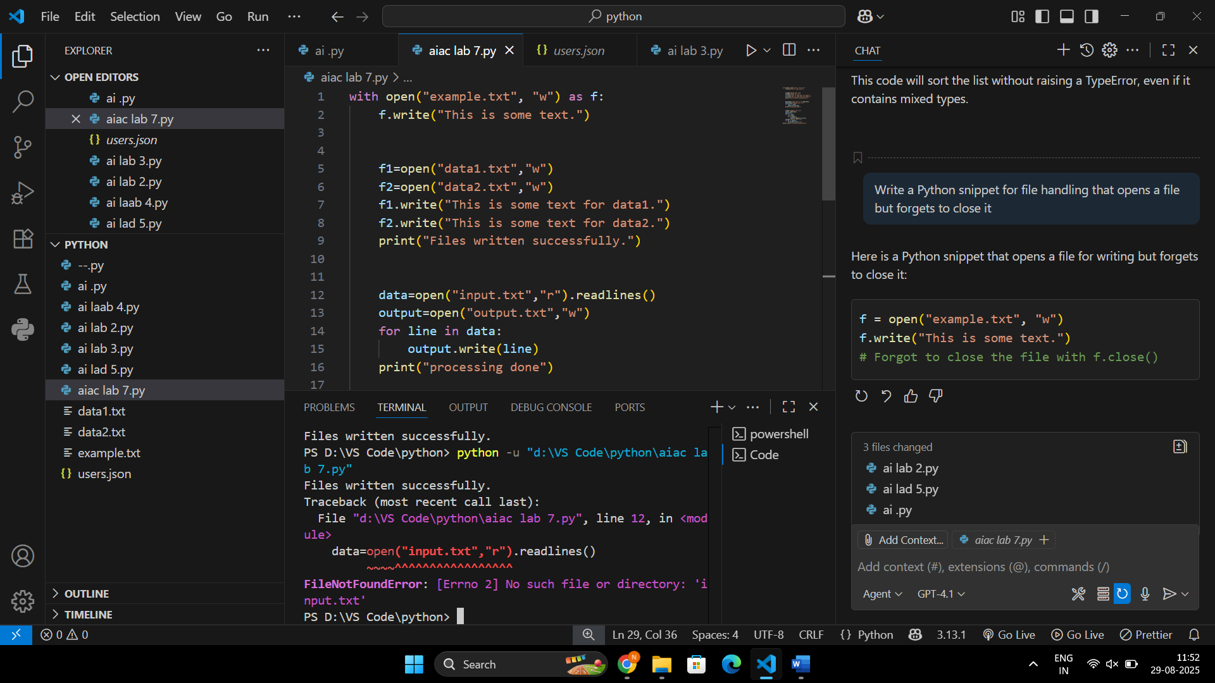

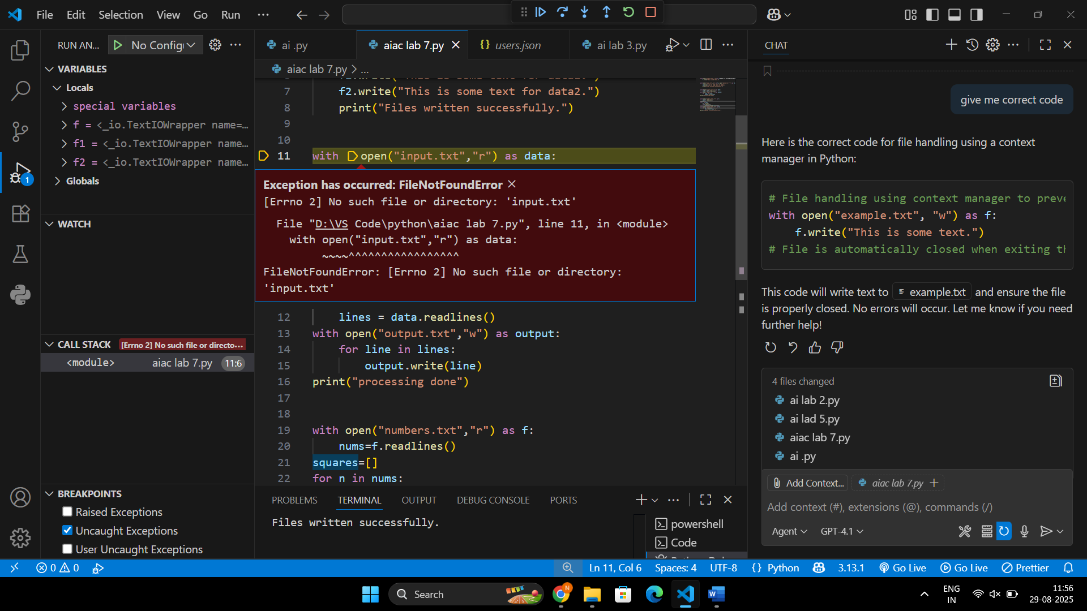

Expected Outcome #3:  
• AI refactors the code to use a context manager, preventing resource leakage and runtime warnings.

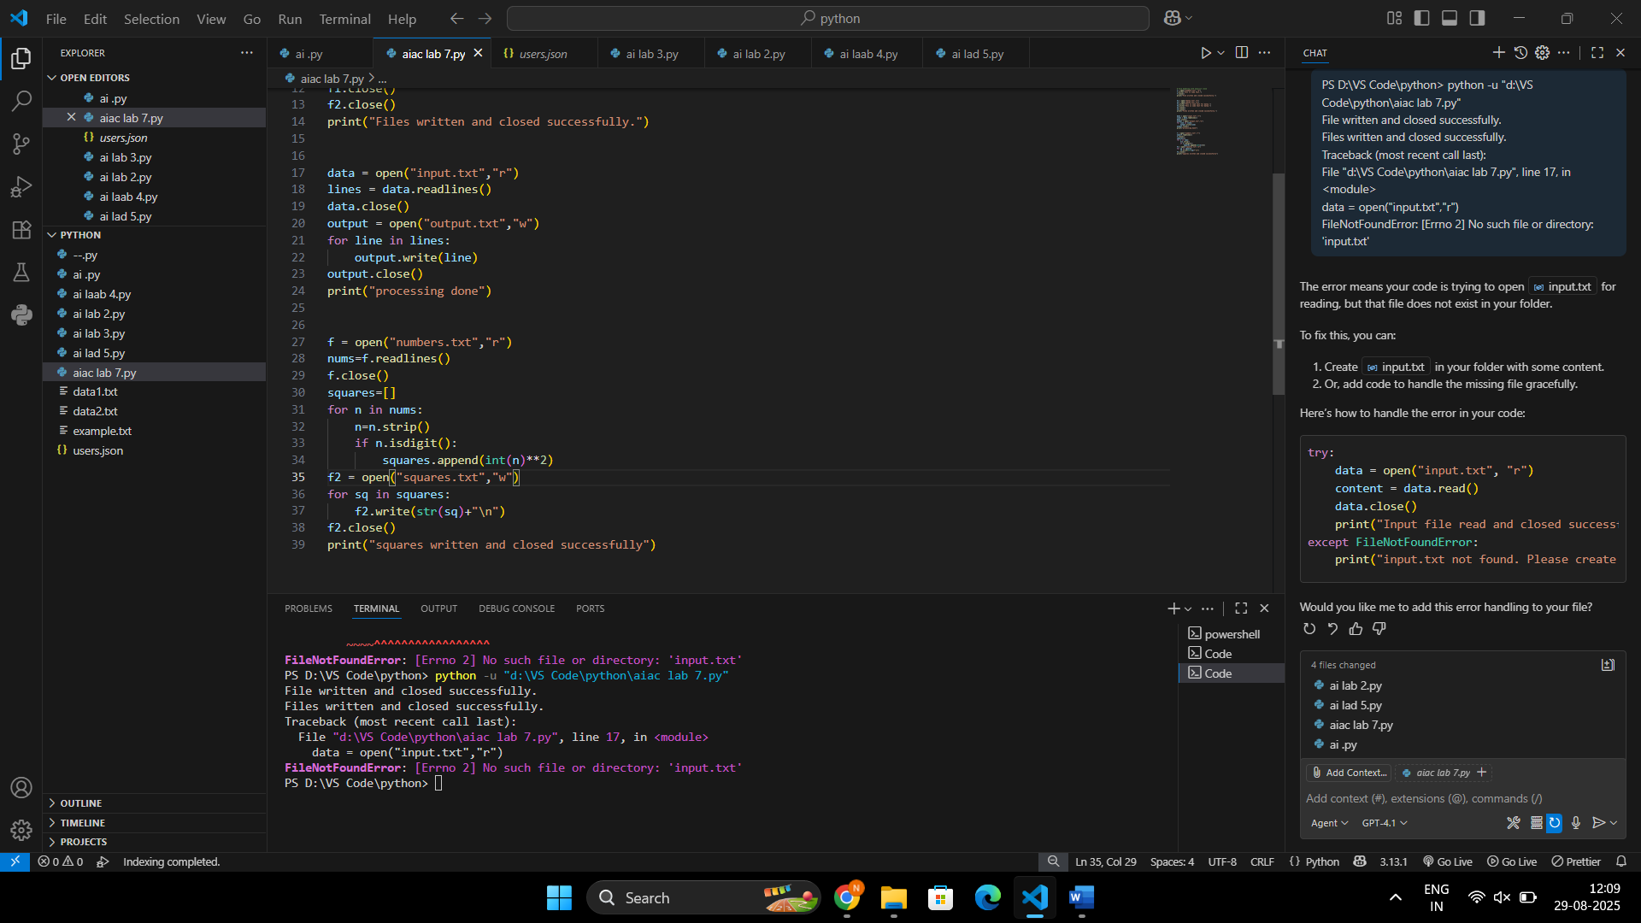

Task Description #4:  
• Provide a piece of code with a ZeroDivisionError inside a loop

Prompt: 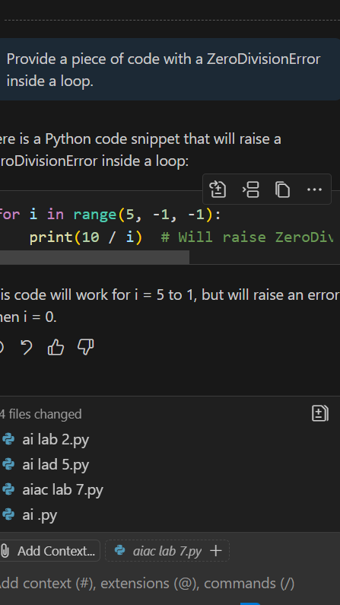

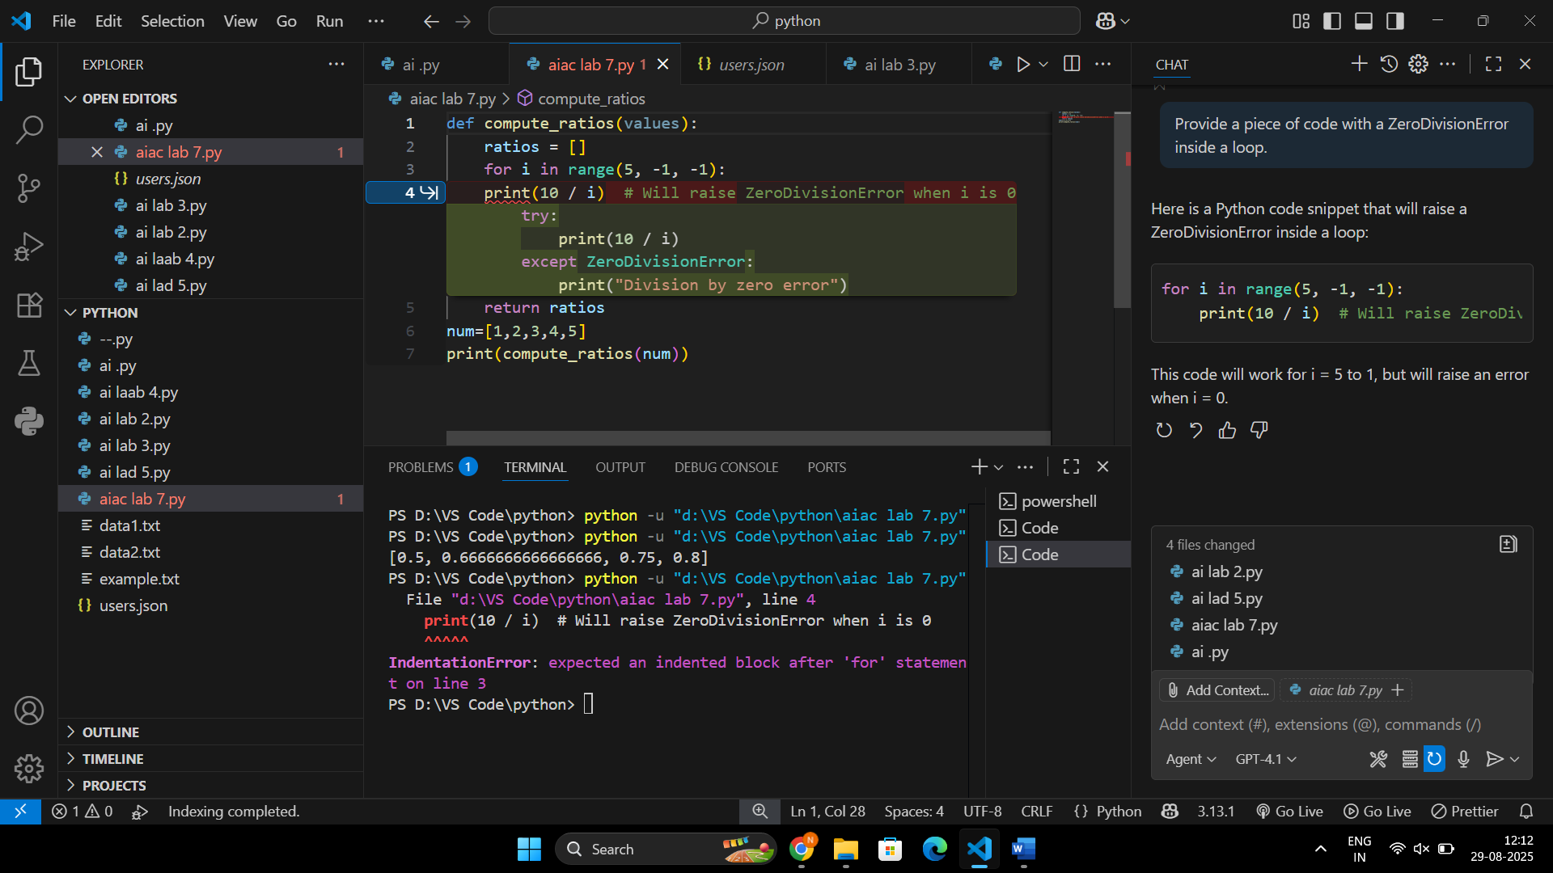

Expected Outcome #4:  
• Copilot adds a try-except block around the risky operation, preventing crashes and printing a  
meaningful error message

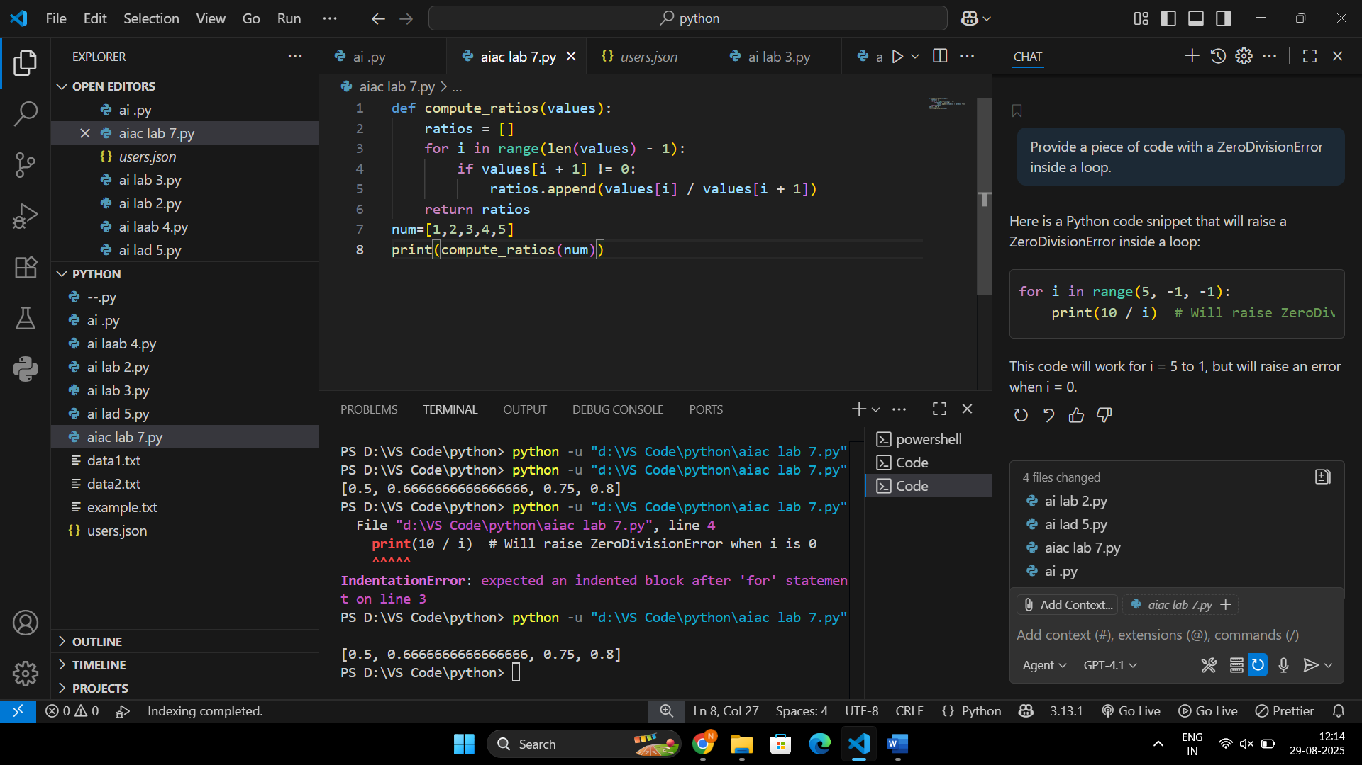

Task Description #5:  
• Include a buggy class definition with incorrect __init__ parameters or attribute references. Ask AI  
to analyze and correct the constructor and attribute usage. 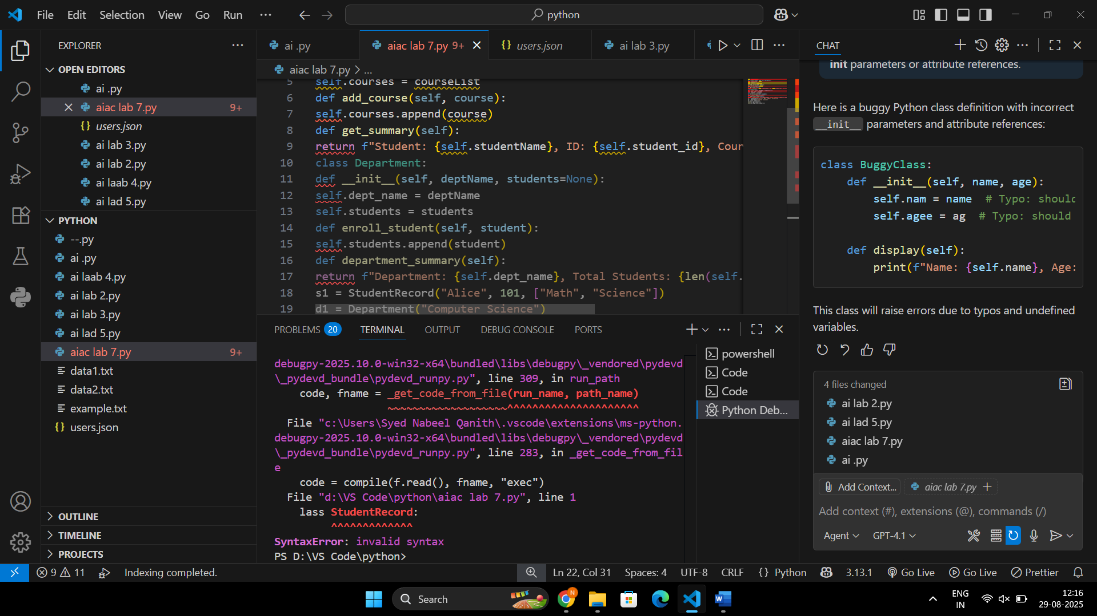

Expected Outcome #5:  
• Copilot identifies mismatched parameters or missing self references and rewrites the class with  
accurate initialization and usage.

